1-5)circle-graph given here shows the spendings of a country on various sports during a particular year. Study the graph carefully and answer the questions given below it.

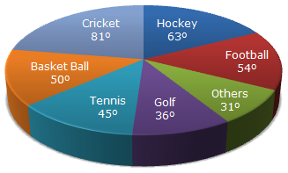

1) What percent of total spending is spent on Tennis?

A 12.5%

B. 22.5%

C. 25%

D. 45%

2)How much percent more is spent on Hockey than that on Golf?

A. 27%

B. 35%

C. 37.5%

D. 75%

3) If the total amount spent on sports during the year be Rs. 1,80,00,000 , the amount spent on Basketball exceeds on Tennis by:

A. Rs. 2,50,000

B. Rs. 3,60,000

C. Rs. 3,75,000

D. Rs. 4,10,000

4)How much percent less is spent on Football than that on Cricket?

A. 22 %

B. 27%

C. 33.33%

D. 37%

5) If the total amount spent on sports during the year was Rs. 2 crores, the amount spent on Cricket and Hockey together was:

A. Rs. 8,00,000

B. Rs. 80,00,000

C. Rs. 1,20,00,000

D. Rs. 1,60,00,000

6-10)Study the following graph carefully and answer the questions given below:

Distribution of candidates who were enrolled for MBA entrance exam and the candidates (out of those enrolled) who passed the exam in different institutes:

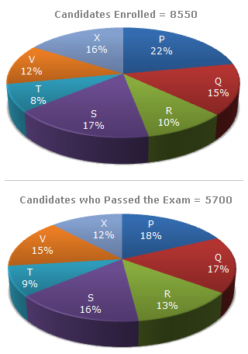

6) What percentage of candidates passed the Exam from institute T out of the total number of candidates enrolled from the same institute?

A. 50%

B. 62.5%

C. 75%

D. 80%

7) Which institute has the highest percentage of candidates passed to the candidates enrolled?

A. Q

B. R

C. V

D. T

8) The number of candidates passed from institutes S and P together exceeds the number of candidates enrolled from institutes T and R together by:

A. 228

B. 279

C. 399

D. 407

9) What is the percentage of candidates passed to the candidates enrolled for institutes Q and R together?

A. 68%

B. 80%

C. 74%

D. 65%

10) What is the ratio of candidates passed to the candidates enrolled from institute P?

A. 9 : 11

B. 14 : 17

C. 6 : 11

D. 9 : 17

11-15)The bar graph given below shows the data of the production of paper (in lakh tonnes) by three different companies X, Y and Z over the years.

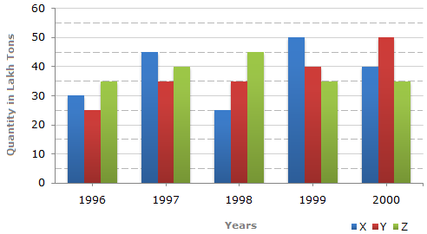

11) For which of the following years, the percentage rise/fall in production from the previous year is the maximum for Company Y?

A. 1997

B. 1998

C. 1999

D. 2000

12) What is the ratio of the average production of Company X in the period 1998-2000 to the average production of Company Y in the same period?

A. 1:1

B. 15:17

C. 23:25

D. 27:29

13) The average production for five years was maximum for which company?

A. X

B. Y

C. Z

D. X and Z both

14) In which year was the percentage of production of Company Z to the production of Company Y the maximum?

A. 1996

B. 1997

C. 1998

D. 1999

15) What is the percentage increase in the production of Company Y from 1996 to 1999?

A. 30%

B. 45%

C. 50%

D. 60%

16-20) The bar graph given below shows the percentage distribution of the total expenditures of a company under various expense heads during 2003.

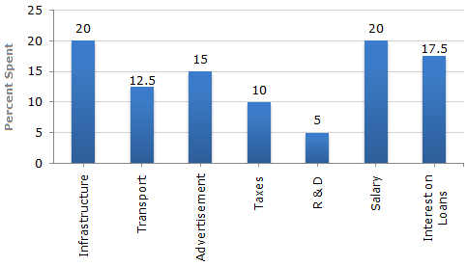

16) The total amount of expenditures of the company is how many times of expenditure on research and development?

A. 27

B. 20

C. 18

D. 8

17) If the expenditure on advertisement is 2.10 crores then the difference between the expenditure on transport and taxes is?

A. Rs. 1.25 crores

B. Rs. 95 lakhs

C. Rs. 65 lakhs

D. Rs. 35 lakhs

18) What is the ratio of the total expenditure on infrastructure and transport to the total expenditure on taxes and interest on loans?

A. 5:4

B. 8:7

C. 9:7

D. 13:11

19) If the interest on loans amounted to Rs. 2.45 crores then the total amount of expenditure on advertisement, taxes and research and development is?

A. Rs. 7 crores

B. Rs. 5.4 crores

C. Rs. 4.2 crores

D. Rs. 3 crores

20) The expenditure on the interest on loans is by what percent more than the expenditure on transport?

A. 5%

B. 10%

C. 20%

D. 40%

21-25) Two different finance companies declare fixed annual rate of interest on the amounts invested with them by investors. The rate of interest offered by these companies may differ from year to year depending on the variation in the economy of the country and the banks rate of interest. The annual rate of interest offered by the two Companies P and Q over the years are shown by the line graph provided below.

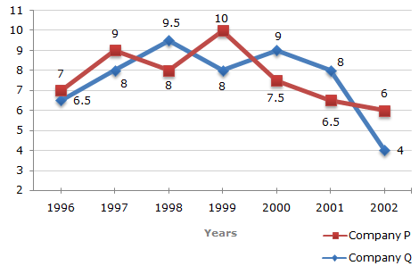

21) A sum of Rs. 4.75 lakhs was invested in Company Q in 1999 for one year. How much more interest would have been earned if the sum was invested in Company P?

A. Rs. 19,000

B. Rs. 14,250

C. Rs. 11,750

D. Rs. 9500

22) If two different amounts in the ratio 8:9 are invested in Companies P and Q respectively in 2002, then the amounts received after one year as interests from Companies P and Q are respectively in the ratio?

A. 2:3

B. 3:4

C. 6:7

D. 4:3

23) In 2000, a part of Rs. 30 lakhs was invested in Company P and the rest was invested in Company Q for one year. The total interest received was Rs. 2.43 lakhs. What was the amount invested in Company P?

A. Rs. 9 lakhs

B. Rs. 11 lakhs

C. Rs. 12 lakhs

D. Rs. 18 lakhs

24) An investor invested a sum of Rs. 12 lakhs in Company P in 1998. The total amount received after one year was re-invested in the same Company for one more year. The total appreciation received by the investor on his investment was?

A. Rs. 2,96,200

B. Rs. 2,42,200

C. Rs. 2,25,600

D. Rs. 2,16,000

25) An investor invested Rs. 5 lakhs in Company Q in 1996. After one year, the entire amount along with the interest was transferred as investment to Company P in 1997 for one year. What amount will be received from Company P, by the investor?

A. Rs. 5,94,550

B. Rs. 5,80,425

C. Rs. 5,77,800

D. Rs. 5,77,500